Sandilands Shanty Men

Song Choruses

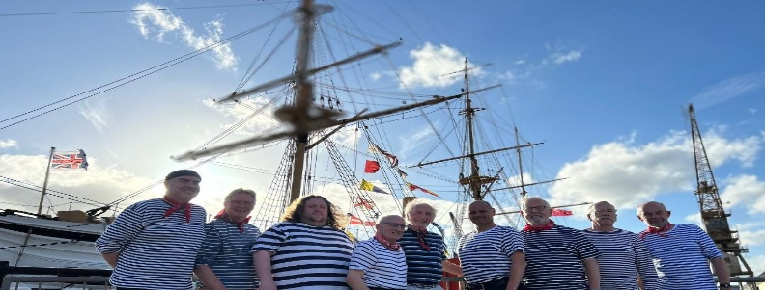

We may not sing all the songs, might include others, and won't follow the alphabetical order! We may even forget a few “worms” along the way. But we hope that you will find the song by the second chorus (if it’s there), so please do join in!

Our contact details are on the back page

Table of Contents
Front Page Booklet Intro 1
A Drop Of Nelson’s Blood 4
All For Me Grog 4
A Jolly Rovin’ Tar 5
A Roving 5
Away, Rio! 6
Bonny Ship The Diamond 6
Bully In The Alley 7
Blow Ye Winds 7
Carrying Nelson Home 8
Chicken On A Raft 8
Deep Blue Swell 9
Don’t Take The Heroes 10
Drunken Sailor 10
Fireship 11
Haul Away Joe 11
John Kanaka 12
Johnny Comes Down To Hilo 12
Leaving Of Liverpool 13
Maggie Mae 13
Mermaid 14
Mingulay Boat Song 14
Old Maui 15
One More Pull 15
Paddy Lay Back 16
Randy Dandy Oh! 16
Retirement Song 17
Rolling Down The River 17
Row On, Row On 18
Wellerman 18
Wild Rover 19
A Bit About Us 20

  - A Drop Of Nelson’s Blood

AND WE’LL ROLL THE OLD CHARIOT ALONG
WE’LL ROLL THE OLD CHARIOT ALONG
WE’LL ROLL THE OLD CHARIOT ALONG
AN’ WE’LL ALL HANG ON BEHIND

  - All For Me Grog

AND ITS ALL FOR ME GROG
ME JOLLY, JOLLY GROG
ALL FOR ME BEER AN’ TOBACCO
WELL, I SPENT ALL ME TIN
WITH THE LADS JUST DRINKIN’ GIN
FAR ACROSS THE WESTERN OCEAN I MUST WANDER

  - A Jolly Rovin’ Tar

COME ALONG, COME ALONG
ME JOLLY BRAVE BOYS
THERE’S PLENTY OF GROG IN THE JAR
WE’LL PLOW THE BRINY OCEAN
LIKE A JOLLY ROVIN’ TAR

  - A Roving

A-ROVING, A-ROVING,
SINCE ROVING’S BEEN MY ROO-AYE-IN
I’LL GO NO MORE A-ROVING
WITH YOU, FAIR MAID

  - Away, Rio!

  - AND IT’S AWAY, RIO, AWAY RIO!
  - SING FARE THEE WELL
  - MY BONNY YOUNG GIRLS
  - AND WE’RE BOUND FOR THE RIO GRANDE

  - Bonny Ship The Diamond

  - AND IT’S CHEER UP ME LADS
  - LET YOUR HEARTS NEVER FAIL
  - FOR THE BONNY SHIP THE DIAMOND
  - GOES A FISHING FOR THE WHALE

  - Bully In The Alley

  - HELP ME BOB, I’M BULLY IN THE ALLEY
  - WAY, HAY! BULLY IN THE ALLEY
  - HELP ME BOB I’M BULLY IN THE ALLEY
  - BULLY DOWN IN SHINBONE AL!

  - Blow Ye Winds

SINGING BLOW YE WINDS IN THE MORNIN’
BLOW YE WINDS, HI HO!
CLEAR AWAY YOUR RUNNIN’ GEAR AND BLOW, BOYS BLOW!

  - Carrying Nelson Home
  - BILLY RUFFIANS HOMEWARD BOUND
  - PUT HIM IN HIS BURIAL GROUND
  - WE’RE CARRYING NELSON HOME
  - WE’RE CARRYING NELSON HOME

  - Chicken On a Raft
  - CHICKEN ON A RAFT ON A MONDAY MORNING
OH WHAT A TERRIBLE SIGHT TO SEE
DABTOES FORWARD AND THE DUSTMEN AFT
SITTING THERE PICKING AT A CHICKEN ON A RAFT
HI-OH, CHICKEN ON A RAFT
EY-OH, CHICKEN ON A RAFT
HI-OH, CHICKEN ON A RAFT
HEY-OH, CHICKEN ON A RAFT
  - Deep Blue Swell

OH, THE DEEP BLUE SWELL
THIS COULD BE OUR LAST FAREWELL
OH, THE DEEP BLUE SWELL
GOTTA MAKE SOME MONEY
OH, THE DEEP BLUE SWELL
WIND IS UP AND YOU NEVER CAN TELL
OH, THE DEEP BLUE SWELL
GOTTA MAKE SOME MONEY

  - Don’t Take The Heroes

DON’T TAKE THE HEROES WHO ANSWER THE CALL
DON’T TAKE THE HEROES RETURN THEM TO SHORE
YOU’RE WINNING THE BATTLE FOR LIVES LOST AT SEA
SO DON’T TAKE THE HEROES, DON’T TAKE THE HEROES
THEY’RE FATHERS AND BROTHERS AND SONS JUST LIKE ME

  - Drunken Sailor
OO RAY, AN UP SHE RISES!
OO RAY, AN UP SHE RISES!
OO RAY AN UP SHE RISES!
EARLEYE IN THE MORNIN’!
  - Fireship

SHE HAD A DARK AND A ROVING EYE-EYE-EYE
AND HER HAIR HUNG DOWN IN RING-ER-LETS
SHE WAS A NICE GIRL, A DECENT GIRL
BUT - ONE OF THE RAKISH KIND

  - Haul Away Joe
AWAY, WAY, HAUL AWAY
WE’LL HAUL AWAY TOGETHER
AWAY, HAUL AWAY
WE’LL HAUL AWAY, JOE!
AWAY, WAY, HAUL AWAY
WE’LL HAUL FOR BETTER WEATHER
AWAY, HAUL AWAY
WE’LL HAUL AWAY, JOE!
  - John Kanaka

TOO LIE AY, OH!
TOO LIE AY
JOHN KANAKA NAKA
TOO LIE AY

  - Johnny Comes Down To Hilo

WHEN JOHNNY COMES DOWN TO HILO POOR OLD MAN!
OH, WAKE HER! OH, SHAKE HER!
OH, WAKE THAT GAL WITH THE BLUE DRESS ON
WHEN JOHNNY COMES DOWN TO HILO POOR OLD MAN!
  - Leaving Of Liverpool

SO FARE THEE WELL, MY OWN TRUE LOVE
WHEN I RETURN, UNITED WE WILL BE
IT'S NOT THE LEAVING OF LIVERPOOL THAT GRIEVES ME
BUT, MY DARLING, WHEN I THINK OF THEE

  - Maggie Mae

  - OH, MAGGIE MAGGIE MAE
  - THEY HAVE TAKEN HER AWAY
  - SHE’LL NEVER WALK DOWN LIME STREET ANYMORE
  - SHE ROBBED SO MANY SAILORS
  - AND CAPTAINS OF THE WHALERS
  - THAT DIRTY ROBBIN’ NO GOOD MAGGIE MAE!
  - Mermaid
AND THE OCEAN WAVES WILL ROLL AND THE STORMY WINDS WILL BLOW
AND WE POOR SAILORS ARE SKIPPING UP ALOFT
AND THE LANDLUBBERS LYING DOWN BELOW, BELOW, BELOW
AND THE LANDLUBBERS LYING DOWN BELOW

  - Mingulay Boat Song

HEEL YA HO BOYS, LET HER GO BOYS
BRING HER HEAD ROUND IN TO THE WEATHER
HEEL YA HO BOYS, LET HER GO BOYS
SAILING HOMEWARD TO MINGULAY

  - Old Maui

ROLLING DOWN TO OLD MAUI ME BOYS
ROLLING DOWN TO OLD MAUI
WE’RE HOMEWARD BOUND
FROM THE ARCTIC GROUND
ROLLING DOWN TO OLD MAUI

  - One More Pull

IT’S ONE MORE PULL, BOYS
THAT’LL DO BOYS
SOON WE’LL DRAW ALONGSIDE
HOIST HER UPWARDS
SWING HER INBOARD
FOR OUR JOURNEYS NEARLY DONE

  - Paddy Lay Back

PADDY LAY BACK
TAKE IN YER SLACK
TAKE A TURN AROUND THE CAPSTAN, HEAVE A PAWL
ABOUT SHIPS STATION BOYS BE HANDY
WE’RE BOUND FOR VALPARISO ROUND THE HORN!

  - Randy Dandy Oh!

HEAVE A PAWL, OH HEAVE AWAY
WAY, HEY! ROLL AN’ GO
THE ANCHORS ON BOARD AND THE CABLES ALL STORED
TO BE ROLLICKIN’ RANDY DANDY OH!
  - Retirement Song

  - I’LL BE A MAN OF THE LAND
  - I’LL BE A MAN OF THE TREES
  - I’LL BE A MAN WHEREVER MY WOMAN WILL BE
  - I WONT BE ANY CAPTAINS MATE
  - I WONT BE SERVANT OF THE SEA CAUSE THIS PRETTY LITTLE WOMAN IS ALL I NEED

  - Rolling Down The River

ROLLING UP AND ROLLING DOWN
WE'LL ALL GET DRUNK IN TILBURY TOWN
TWENTY FOUR HOURS TO TURN AROUND
AND GO ROLLING DOWN THE RIVER!
  - Row On
ROW ON, ROW ON, ANOTHER DAY
MAY SHINE WITH BRIGHTER LIGHT
PLY, PLY THE OARS & PULL AWAY
THOU MUST NOT COME TONIGHT

  - Wellerman

SOON MAY THE WELLERMAN COME TO BRING US SUGAR AND TEA AND RUM
ONE DAY WHEN THE TONGUING IS DONE
WE’LL TAKE OUR LEAVE AND GO!

  - Wild Rover

AND ITS NO, NAY, NEVER!
NO NAY NEVER NO MORE
WILL I BE THE WILD ROVER
NO NEVER, NO MORE!

A Bit About Us
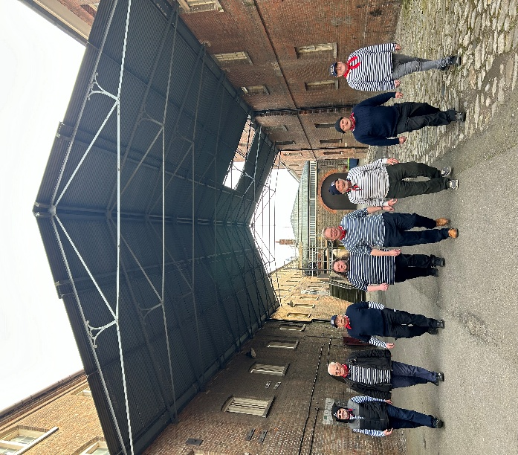

Formed during Covid lockdown, we are part of the Croydon Male Voice Choir (Registered Charity) and always keen to perform, both indoors and out.
You can reach us on:
FB:www.facebook.com/profile.php?id=61557873022263
Web: www.sandilandsshantymen.uk
Email: sandilandsshantymen@gmail.com
May fair winds always greet you!

